***FRONTEND:***

1. Filters and Sort on Clinic Search page
2. Add review
   1. Page to be recreated by Mandeep
3. Show Package info on search Result page
   1. Design to be created by Mandeep
4. Check **request free quote, add clinic** and **contact** forms
5. Blog page -- form on the right to submit a request + search area

***BACKEND:***

1. Use SEO Title and SEO Desc in template (Clinic Page)
2. Use images of doctors in template (Clinic Page __ Doctor’s Section)
3. After importing a three databases, their status will be pending until it is finalized with photos and missing information.
4. Add review with fields - ( review, name, mail) and ratings of –
   1. Quality
   2. Service
   3. Cleanliness
   4. Comfort
   5. Communication
5. Request free quote full functionality remaining

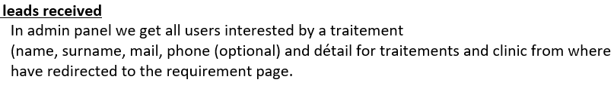

1. Dynamic Content Translation + Static Content Translation